|  |
| --- |
| Serial No: |
| **Final**  **Part B** |
| **Total Time: 2 Hours** |
| **Total Marks: 100** |
| ________________  Signature of Invigilator |

|  |
| --- |
| **CS-307 Computer Networks** |
| Friday, December 23, 2016 |
| **Course Instructors** |
| Dr. Ehatsham zahoor, Dr. M. Asim  and Mr. Jawad Hassan |

|  |
| --- |
| **______________________________ _________ ______ _____________________**  Student NameRoll No Section Signature |

## DO NOT OPEN THE QUESTION BOOK OR START UNTIL INSTRUCTED.

**Instructions:**

1. Attempt on question paper. Attempt all of them. Read the question carefully, understand the question, and then attempt it.
2. No additional sheet will be provided for rough work.
3. After asked to commence the exam, please verify that you have **Fourteen (14)** different printed pages including this title page. There are total of **five (5)** questions.
4. Use permanent ink pens only. Any part done using soft pencil will not be marked and cannot be claimed for rechecking.

|  |  |  |  |  |  |  |
| --- | --- | --- | --- | --- | --- | --- |
|  | Q-1 | Q-2 | Q-3 | Q-4 | Q-5 | **Total** |
| **Marks Obtained** |  |  |  |  |  |  |
| **Total**  **Marks** | 50 | 20 | 10 | 10 | 10 | **100** |

**Vetted By: _____________________________ Vetter Signature: _____________________**

**Question 1: Topic – Synthesis [50 Points]**

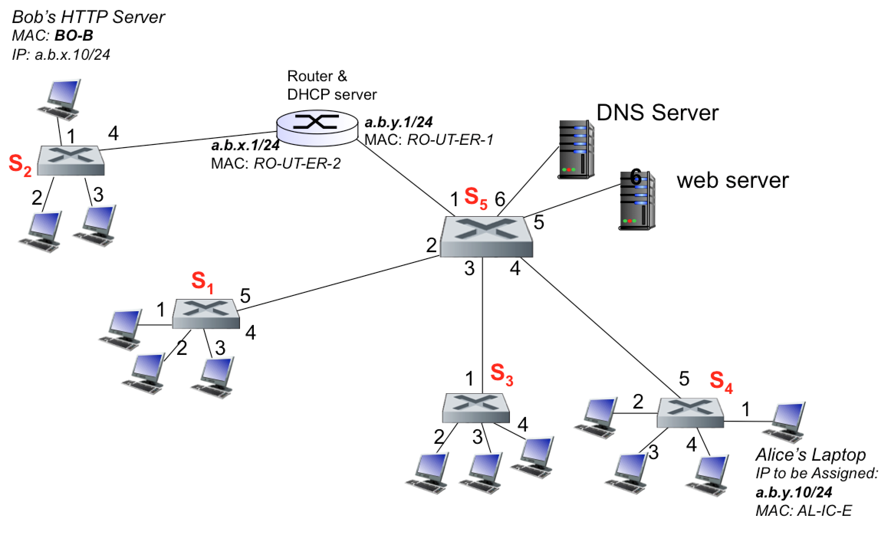

The network diagram above shows a typical university network setup. There are five switches S1 – S5. For the start we would assume that all Switch Tables (and so as ARP Tables) are empty. There are two subnets, ***a.b.x.0/24 and a.b.y.0/24***, separated by a router that also acts as the DHCP server. Switch S2 is not in the same subnet as of other switches.

We identify few end systems here; Alice wants to join the network and should be assigned an IP address, ***a.b.y.10/24***. She wants to access a Webpage, <http://www.IamBob.com/ForAlice.html>. As you can understand, Bob has created a special Web page for Alice – its contents doesn’t matter in relation to this question but you know are free to share your thoughts on this! Bob is already there on the network but not in the same subnet and is running a Webserver at the assigned IPaddress, ***a.b.x.10/24****.* The Website <http://www.IamBob.com>, maps to this IP address. The MAC addresses of the different end systems are also shown in the figure.

While in a computer lab (where all systems are connected with switch S4), Alice plugs network cable in her Laptop. In the introductory class of our course, we studied that we will (only) study protocols in this course and there is a lot going on “under the hood” (actually more than we studied) even when you access a simple Web page. In this question, you are guided step by step to some of the protocols used to access a Web page, with question posed after some review.

***Note: You need to be as specific as possible and provide the answers in the space provided. Anything written outside the allocated space (box) would not be considered for evaluation. Use one box for specifying one protocol involved.***

*Step1: IP Address Assignment*

|  |
| --- |
| *ProtocolName and brief description:* DHCP – Allows an end-system to get IP address.  *Layer and Implementation:* Application layer, implemented as a process  Addressing details: In our example it would use UDP with SrcPort 68 and DestPort 67, src IP being o.o.o.o, dest IP being 255.255.255.255. The src mac address is of Alice Laptop and destination MAC address is broadcast.  *Usage in our example:* Alice is connected to Switch S4, as it is assumed to be empty when the switch S4 receives the frame it updates its forwarding table and broadcast it to all interfaces including the one where router is connected. All other end-systems drop the packet, as there is no application listening at port 67. Router does have DHCP application listening at port 67 and once the packet is demultiplexed to DHCP application, it assigns an IP. More than one message is needed to get an IP but due to space limitations I have only showed once. Let us now assume that an IP has been assigned and move on to next protocol. |

***a) What other information (than IP) DHCP server returns and what it is used for?***

|  |
| --- |
| [5 points] |

*Step2: DNS Request/Response*

|  |
| --- |
| *ProtocolName and brief description:* DNS – Provides Name-IP translation  *Layer and Implementation:* Application layer, implemented as a process  *Addressing details:* Uses UDP, destination port 53  *Usage in our example:* The OS on Alice’s system creates a DNS query message, putting the string “http://www.IamBob.com” in the question section of the DNS message. This DNS message is then placed within a UDP segment with a destination port of 53 (DNS server). The UDP segment is then placed within an IP datagram with an IP destination address of a.b.y.5 (the IP address of DNS server) |

***b): How the OS on Alice’s system gets the IP and MAC of the DNS server? Detail complete process and any protocols involved.***

|  |
| --- |
| [7 points] |

***c) How the OS on Alice’s system can decide that the DNS server belongs to same subnet or any other subnet?***

|  |
| --- |
| [3 points] |

***d) Given the OS on Alice’s system knows the IP and MAC of the DNS server, what information is added to the outgoing frame?***

|  |
| --- |
| [3 points] |

***e) How does the Frame reach the DNS server? You need to explain the role of switches, the contents of switch tables and if there is any broadcast how other systems discard this frame?***

|  |
| --- |
| [5 points] |

***f) Once the frame reaches DNS server, how it is demultiplexed to the DNS application running on the server?***

|  |
| --- |
| [2 points] |

***g) Assuming DNS server has a cached entry, how the response reaches Alice’s system? You need to clearly explain the role of switches, show updated switch tables and any broadcasts.***

|  |
| --- |
| [5 points] |

At the end of this step, let us now assume that the OS at Alice’s system now knows the IP address for the Bob’s Website.

*Step3: HTTP Request/Response*

|  |
| --- |
| *ProtocolName and brief description: HTTP – Hypertext transfer protocol*  *Layer and Implementation: Application layer – Implemented as a process*  *Addressing details: Uses TCP, Server listens on port 80 by default*    *Usage in our example: When Alice types Bob’s Website address in the browser, it creates an HTTP request to be sent to the IP address returned by the DNS. The response, the Webpage is received as HTTP response message, containing HTML to be displayed on the browser.* |

***h) Before the request from the Alice’s system is sent to Bob’s Web server, in what state the server is? More precisely is it listening at some port? How many sockets it has? Name them.***

|  |
| --- |
| [3 points] |

***i) HTTP uses TCP as the transport layer protocol. TCP is connection oriented so before the HTTP GET request can be sent, a connection needs to be established. You need to explain in detail how the connection would establish. More specifically you need to specify following information:***

|  |
| --- |
| 1. *For the first connection request packet sent to Bob’s server, show its type and what information makes a normal packet of that type? You need to also show the source and destination PORT, IP and MAC addresses.* [5 points] |

|  |
| --- |
| 1. *For the first connection request packet sent to Bob’s server, show how it reaches the Server. You need to show how the Alice system decides to send it to the router and what router does with the received frame. Show any updated addressing information?*   [5 points] |

|  |
| --- |
| 1. *For the first connection request packet sent to Bob’s server, once the frame reaches the Bob’s server what does it do? Are any data structures updated? What kind of message it sends back. Show its type, the source and destination PORT, IP and MAC addresses.*   [5 points] |

|  |
| --- |
| 1. *Once the response message reaches Alice’s laptop, what kind of message is sent to Bob’s server. This third message can carry data as well but lets assume that there is no data sent.*   [2 points] |

*Alice’s browser creates the HTTP GET message containing the URL to be fetched. The HTTP GET message is then written into the socket, with the GET message becoming the payload of a TCP segment. The TCP segment is placed in a datagram and sent and delivered to Bob’s Web server. The HTTP server then reads the HTTP GET message from the TCP socket, creates an HTTP response message, places the requested Web page content in the body of the HTTP response message, and sends the message into the TCP socket. The message then arrives at the Alice’s system. Web browser program reads the HTTP response from the socket, extracts the html for the Web page from the body of the HTTP response, and finally (finally!) displays the Web page!*

**Question 3 [20 Points]**

1. Consider the following network configuration where private IPs are assigned and router supports NAT.

**[5 marks]**

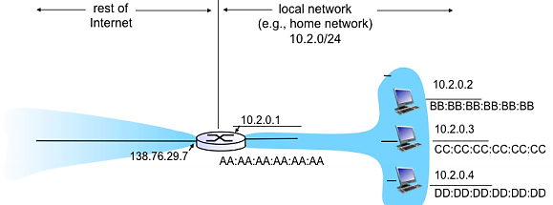

Now assume that the top-most client (10.2.0.2) in the local network sends an HTTP request to <http://www.umass.edu> (IP address: 128.119.103.148). The source port for the TCP connection for this HTTP request is 7000.

Fill out the NAT Table below with the information that would be entered in that table after the HTTP request has been forwarded from the NAT router into the WAN. In addition, specify destination and source IP addresses and ports for the remaining two client using the same port number.

|  |  |
| --- | --- |
| NAT Translation Table | |
|  |  |
|  |  |
|  |  |
|  |  |

When the packet leaves the NAT router, it needs to be routed through the internet to its destination (the UMass web server). For this problem, let’s assume the network shown in the Figure below.

1. Assume node **x** represents the NAT router and node z is the router the UMass web server is connected to. By applying Dijkstra’s shortest-path algorithm, fill out the table below and determine the shortest path from **x** to all other network nodes.

**[10 Points]**

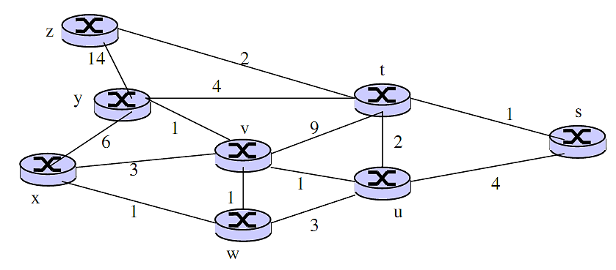

|  |  |  |  |  |  |  |  |
| --- | --- | --- | --- | --- | --- | --- | --- |
| Steps | D (s) | D (t) | D (u) | D (v) | D (w) | D (y) | D (z) |
|  |  |  |  |  |  |  |  |
|  |  |  |  |  |  |  |  |
|  |  |  |  |  |  |  |  |
|  |  |  |  |  |  |  |  |
|  |  |  |  |  |  |  |  |
|  |  |  |  |  |  |  |  |
|  |  |  |  |  |  |  |  |

1. You have been assigned an address of 192.168.101.225 with a subnet mask of 255.255.255.192. Your mission is to identify the number of subnets this address can produce along with the total number of hosts for each subnet. Also, identify the network Id and the broadcast Id for each of the subnet.

**[5 Points]**

**Question 4: [10 Points]**

Because of the connection-oriented nature of TCP, a connection setup phase is required at the beginning of each session, as well as a connection tear-down phase at the end of the session. Enumerate the events below in the order they occur as host A opens a TCP connection to host B, transmits data and then closes the connection. Write a 1 next to the event that occurs first and continue like that until all occurring events are enumerated (the first event has been enumerated for you). You may assume that no segments are lost. Also indicate at which host the event happens. Please note that there might be events listed below that are not a part of the above data transfer and hence should not be enumerated.

|  |  |  |
| --- | --- | --- |
| **Order** | **Host** | **Event** |
|  |  | Send an ACK segment |
|  |  | Do the rest of the data exchange |
|  |  | Close the connection |
|  |  | Send an ACK segment |
|  |  | Send a FIN segment |
| 1 | A | Send a SYN segment |
|  |  | Send a FIN segment |
|  |  | Send a RST segment |
|  |  | Send a SYN-ACK segment |
|  |  | Enter the TIME-WAIT-1 state |
|  |  | Send an ACK+DATA segment |
|  |  | Close the connection |
|  |  | Enter the TIME-WAIT-2 state |

**Question 4 [10 Points]**

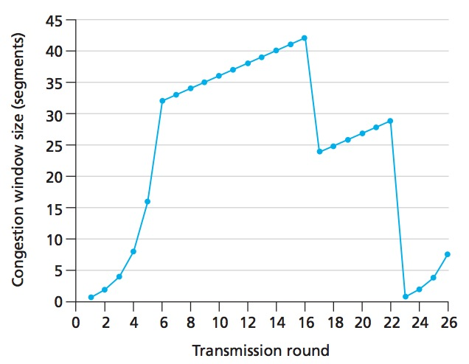

Let’s assume the TCP **Reno** protocol is experiencing the behavior shown above answer the following questions. In all cases, you should justifying your answer. You are not allowed to highlight anything on the figure but rather right the intervals (for instance for part a, your answer would be like “From Transmission Round X till Transmission Round Y”, X and Y being the values you need to decide).

1. Identify the intervals of time when TCP slowstart is operating.
2. Identify the intervals of time when TCP congestion avoidance is operating.
3. After the 16th transmission round, is segment loss detected by a triple duplicate ACK or by a timeout?
4. After the 22nd transmission round, is segment loss detected by a triple duplicate ACK or by a timeout?
5. What is the initial value of ssthresh?
6. What is the value of ssthresh at the 18th transmission round?
7. What is the value of ssthresh at the 24th transmission round?
8. During what transmission round is the 70th segment sent?
9. Assuming a packet loss is detected after the 26th round by the receipt of a triple duplicate ACK, What will be the values of the congestion window size and of ssthresh?

**Question 5 [10 Points]**

1. Consider the following diagram of a LAN composed of three LAN segments connected by a Switch. Assume that the Switch table starts off empty and the given sequence of frames is sent, in the given order (frame 1, frame 2, etc.). As the Switch filters the frames it is using the standard bridge-learning algorithm to fill in its table. For each frame write down to which interfaces (if any) the Bridge forwards the frame (the answer to the first one is filled in for you) Note that it is possible that in some cases the Bridge will drop the frame and not forward it. If this happens you should say so.

🖳

🖳

🖳



A

🖳

🖳

🖳

🖳 🖳 🖳

B

C

D

E

F

I

H

G

3

1

2

|  |  |  |  |
| --- | --- | --- | --- |
| Frame | Source node | Destination node | Bridge forwards frame to interfaces |
| 1 | A | D | 2,3 |
| 2 | H | D |  |
| 3 | C | H |  |
| 4 | G | H |  |
| 5 | E | D |  |
| 6 | B | E |  |